Assignment 4.1 AI ASSITED CODING
Name : EESARI HAMSITHA
Batch : AI 13
Roll.no : 2403A52361

Task 01: Zero-Shot Prompting with Conditional Validation
Prompt: Generate a python function that validates an Indian mobile number using AI.
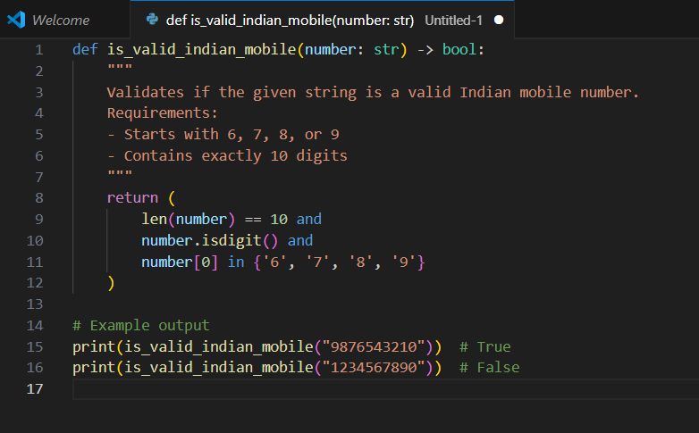

Task 02: One-Shot Prompting with Edge Case Handling
Prompt: Generate a Python function that calculates the factorial of a number using one shot prompting AI
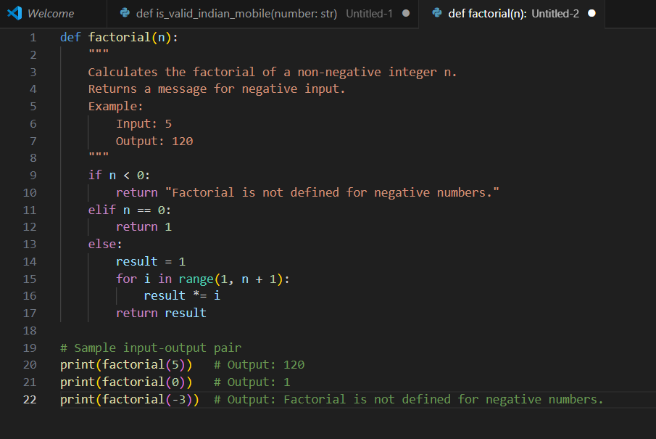

Task 03: Few-Shot Prompting for Nested Dictionary Extraction
Prompt: Instruct the AI to create a function that parses a nested dictionary representing student information using few shots prompting (with 2-3 examples).
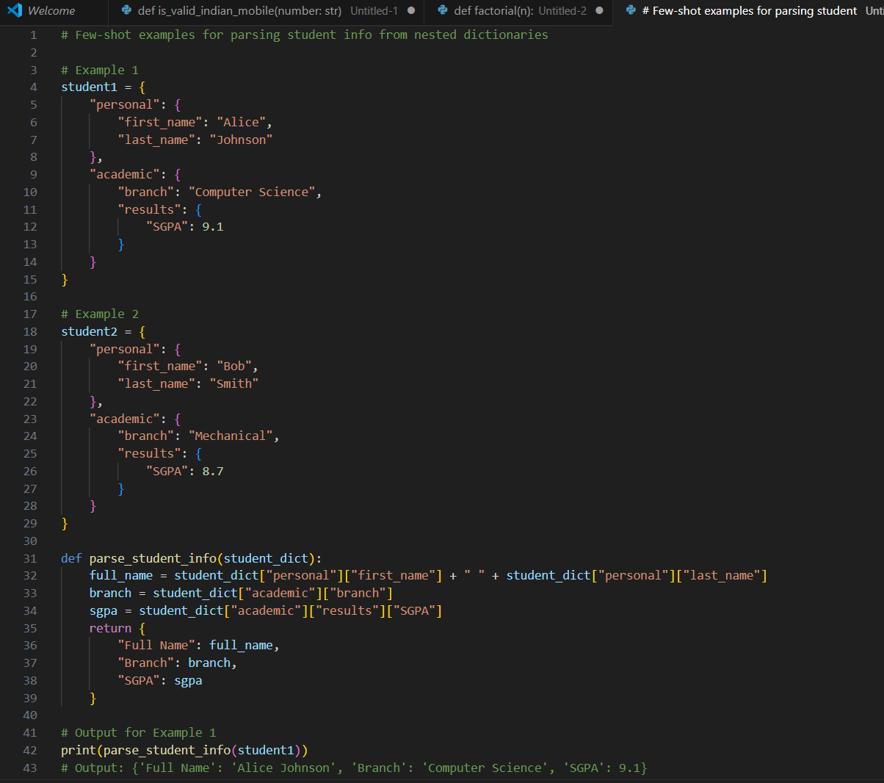
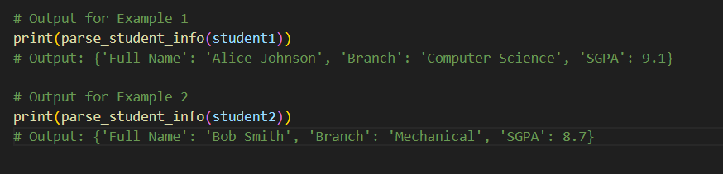

Task 04: Comparing Prompting Styles for File Analysis
Prompt: Experiment with zero-shot, one-shot, and few-shot prompting to generate functions for CSV file analysis.
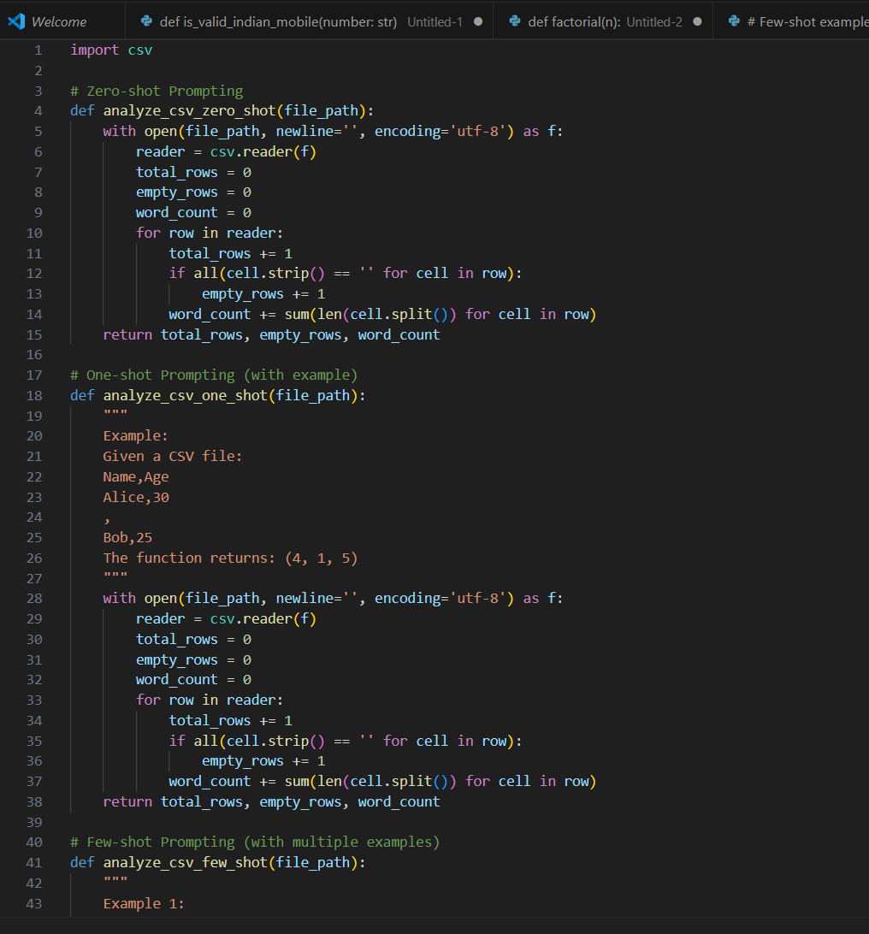
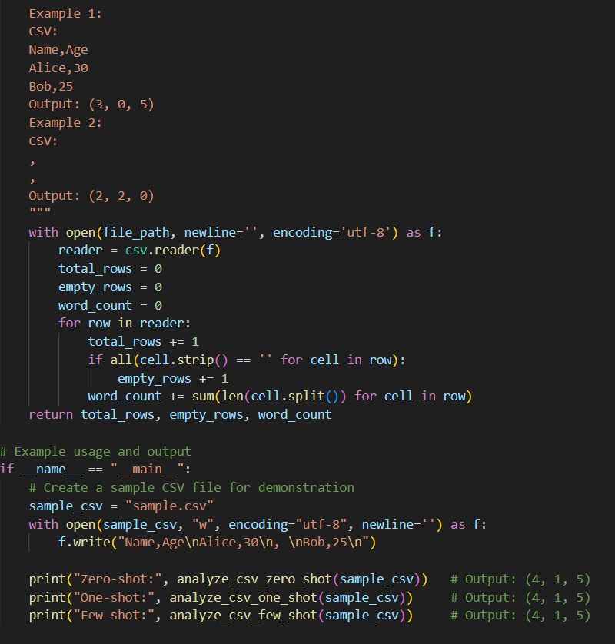
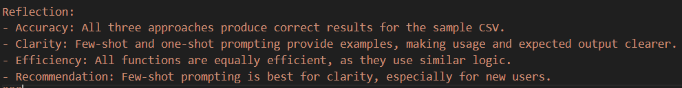

Task 05: Few-Shot Prompting for Text Processing and Word Frequency
Prompt: Use few-shot prompting (with at least 3 examples) to generate a Python function that processes text and analyzes word frequency.
